**TIMER**

In AVR assembly, the **Timer/Counter Control Register** (TCCR) is used to configure and control the behavior of a timer or counter module. Different timers (Timer0, Timer1, Timer2, etc.) have their own control registers, typically named **TCCRn** or variants like **TCCRnA**, **TCCRnB**, where n refers to the timer number.

**Timer1**:

* **16-bit timer**, capable of counting from 0 to 2^{16} - 1 =65,535.
* Offers higher resolution and longer timing intervals.

**Timer0**:

* **8-bit timer**, capable of counting from 0 to 2^{8}−1=255.
* Suitable for tasks requiring shorter intervals and simpler functionality.
* Commonly used for tasks like time delays, square wave generation, or basic PWM (e.g., dimming LEDs, sound tone generation).

**Modes of Operation**

● Normal

● CTC (Clear Timer on Compare Match)

The **CTC (Clear Timer on Compare Match)** mode is chosen for generating a square wave because it is well-suited for precise timing and frequency generation.In **CTC mode**, the timer counts from 0 to a specific value stored in the **Output Compare Register (OCRnA)**. When the counter reaches this value

● Fast PWM (Single Slope PWM)

● Phase Correct PWM (Double Slope PWM)

Mode of Operation is selected by WGMxy registers, where x is Timer ID, and y is the WGM register ID

**SUSU!!!!!**

**TIMER1 registers**

**prescaler**

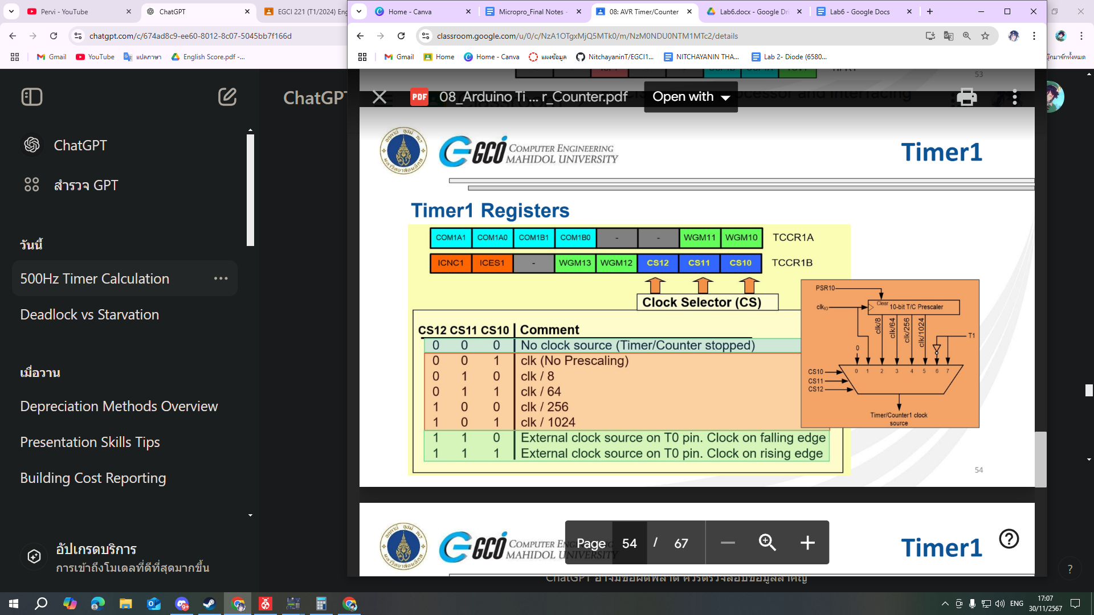

**Mode of Operation**

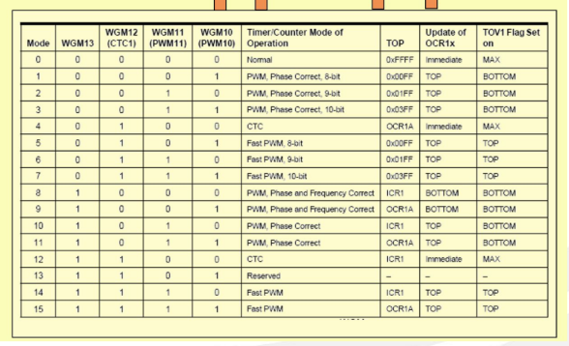

**TIMER0 registers**

**Mode of operation**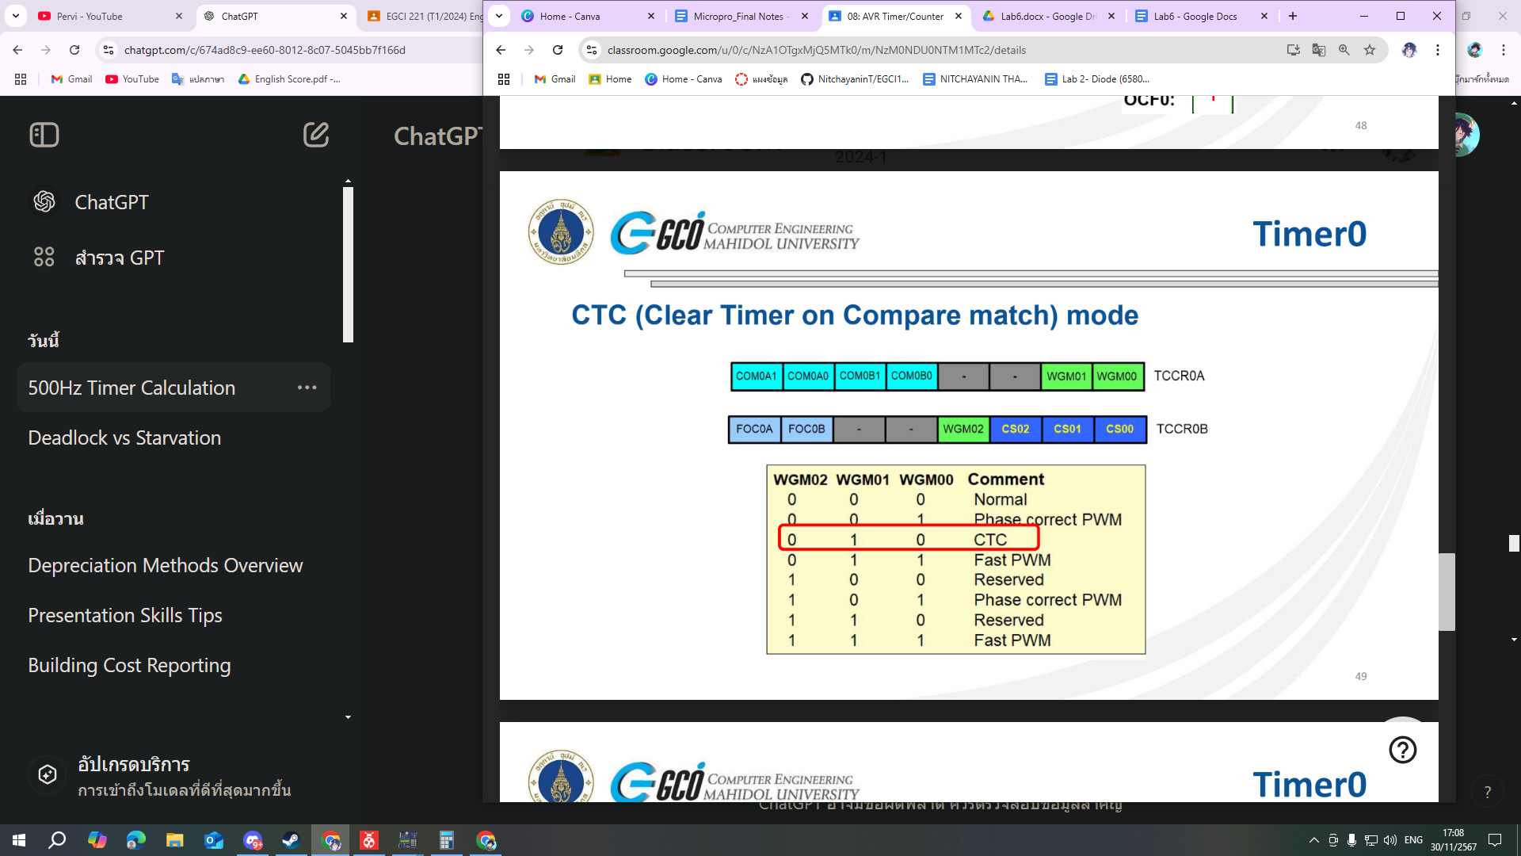

**Prescaler**

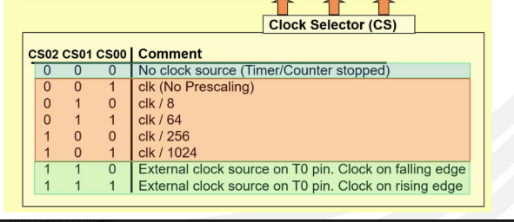**`**

**Timer counter2**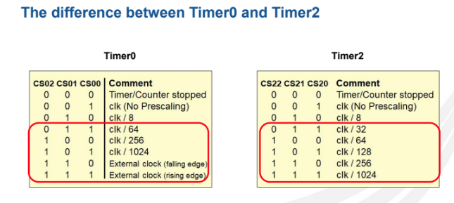

**How to Generate Waveforms (Square wave)??**

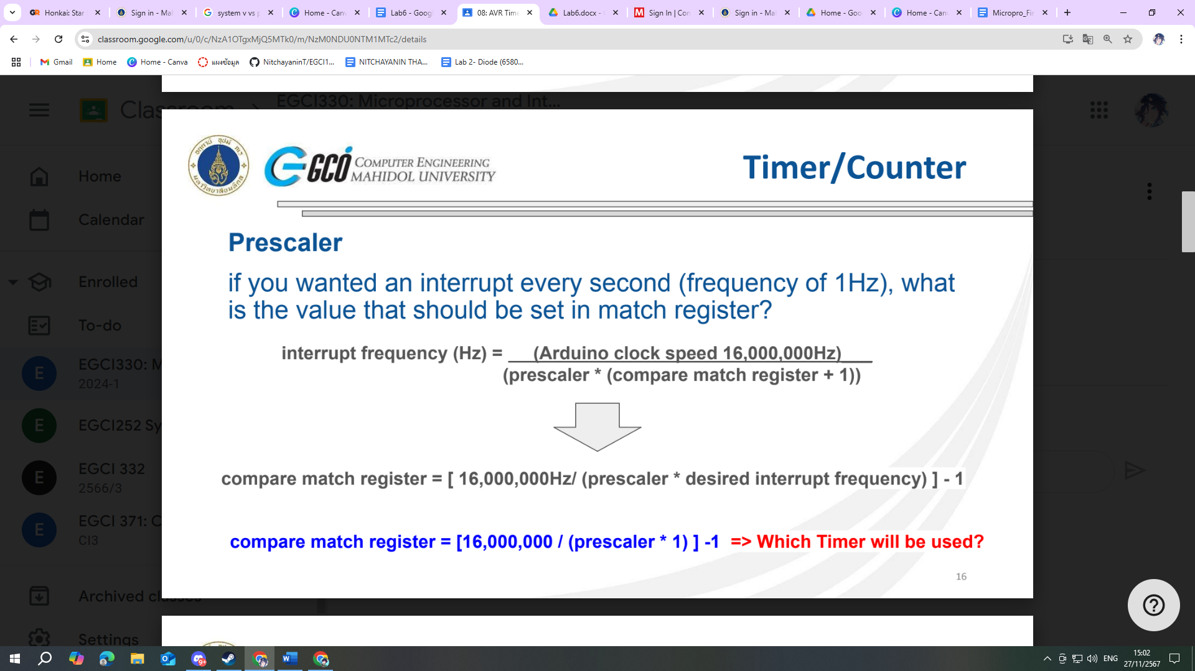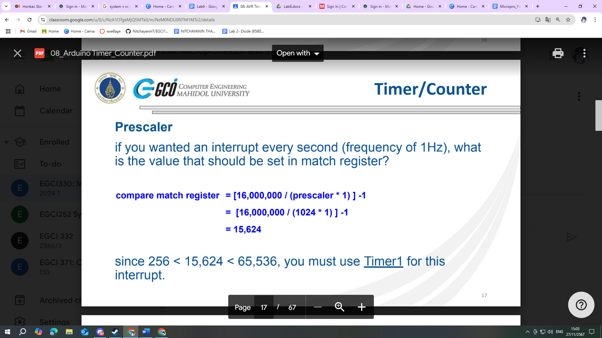

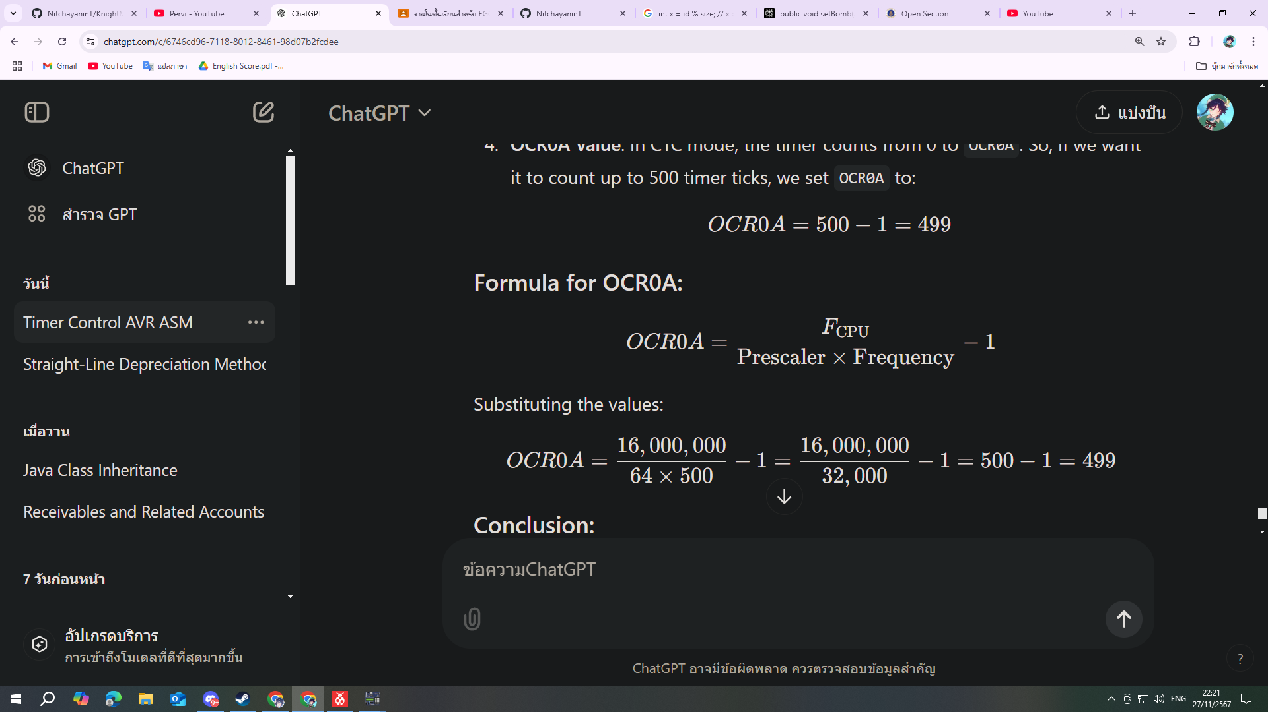

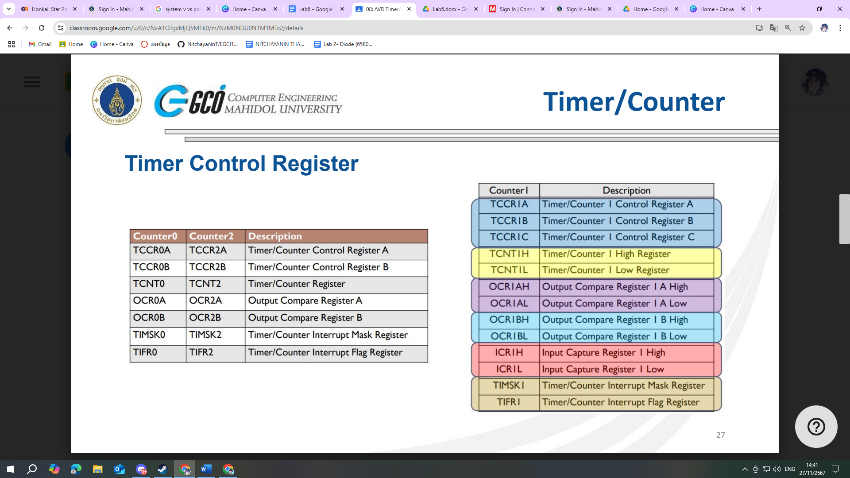

### **TCNT0 is the Timer/Counter Register for Timer 0 in AVR microcontrollers. It is an 8-bit register that holds the current value of Timer 0 as it counts up (or down, in some modes).**

**Tracks Timer Count:**

* TCNT0 shows the current count value of Timer 0.
* It increments (or decrements, in specific modes) at each timer clock cycle.

**Manages Timing and Delays:**

* By monitoring or manipulating TCNT0, you can measure or control the elapsed time.

**Configures Custom Start Points:**

* By writing a value to TCNT0, you can start counting from a specific value rather than from zero. This is useful for shortening the delay time or creating precise intervals.

### **Common Timer Control Registers**

#### **1. TCCRnA (Timer/Counter Control Register A)**

#### **2. TCCRnB (Timer/Counter Control Register B)**

### **Key Registers for Timers**

1. **TCCRnA**: Control settings for the mode of operation (e.g., waveform generation).
2. **TCCRnB**: Control settings for the prescaler and other features.
3. **TCNTn**: Timer/Counter register that holds the current value of the timer.

**Set specific bit to high**

PORTC |= (1 << PORTC0); // Set PORTC.0 high

**Set specific bit to low**

PORTC &= ~(1 << PORTC0);

You want 0.5ms

ATMEGA 16MHz

1/(16*10^6) -> 0.0000000625

TCNT0 = 0-255 How do you count 8000 then

Prescaler

That answers your question? Why do you need a prescaler?

**useful function()**

char hex_to_ASCII(int hex) {

char ascii;

if (hex < 0 || hex > 15)

return '\0';

if (hex >= 0 && hex <= 9)

ascii = '0' + hex;

else

ascii = 'A' + (hex - 10);

return ascii;

}

int ASCII_to_int(char ascii)

{

int i = -1;

if (ascii >= '0' && ascii <= '9')

i = ascii-'0';

else if (ascii >= 'A' && ascii <= 'F')

i = ascii-'A'+10;

return i;

}

void counter_1sec()

{

TCNT1 = 0x0000;

TIFR1 |= (1<<OCF1A); // Clear Flag

while((TIFR1 & (1<<OCF1A))==0)

{

if(reset_button)

break;

}

}

**INTERRUPT**

**-External Interrupt**

**○ Timer Interrupt**

**○ Pin Change Interrupt**

sei (); enable interrupt (global)

cli (): disable interrupt (global)

**Timer interrupt**

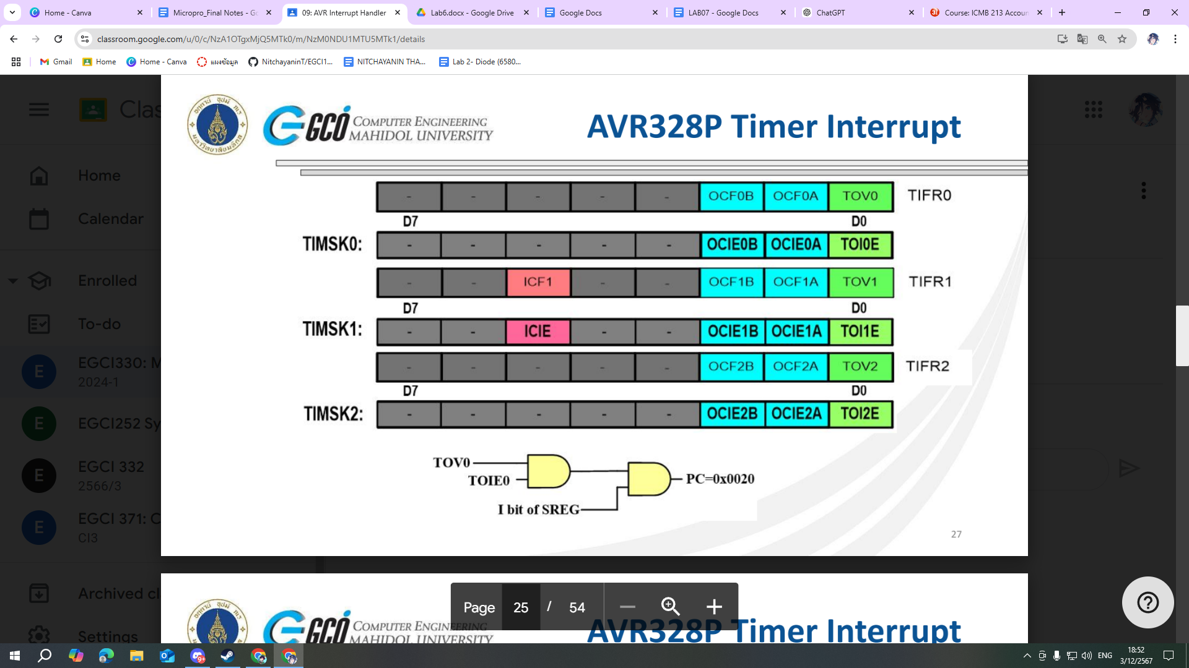

**EXTERNAL INTERRUPT**

● Both external and pin change are interrupts signal which is received from external to the chip

● External Interrupts are limited to only a couple pins (INT0 (PIND2), INT1 (PIND3))

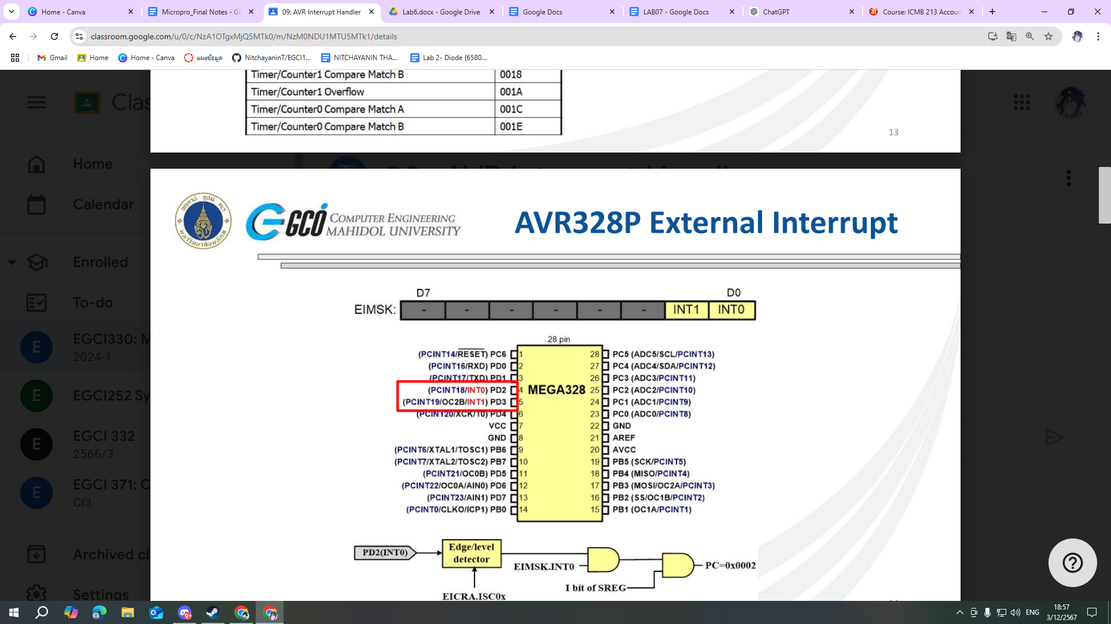

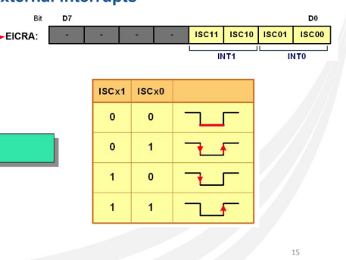

**Pin Change Interrupts**

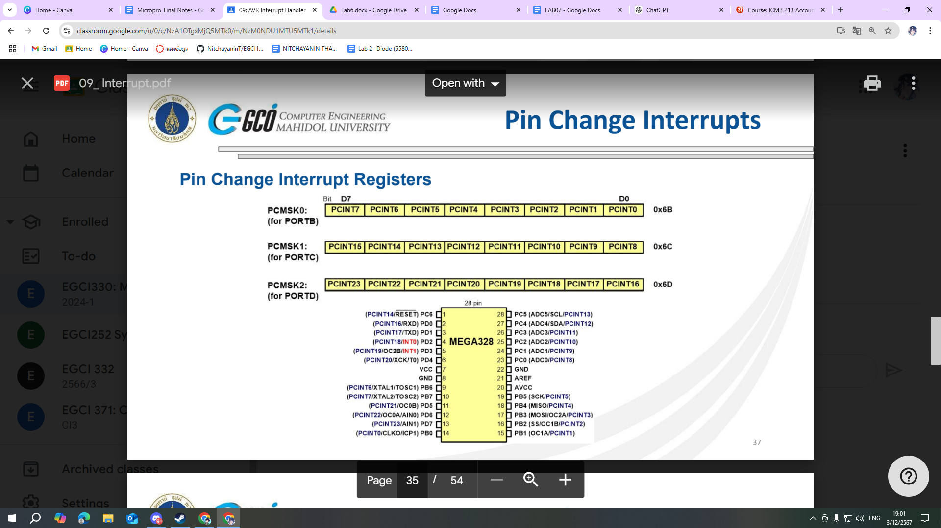

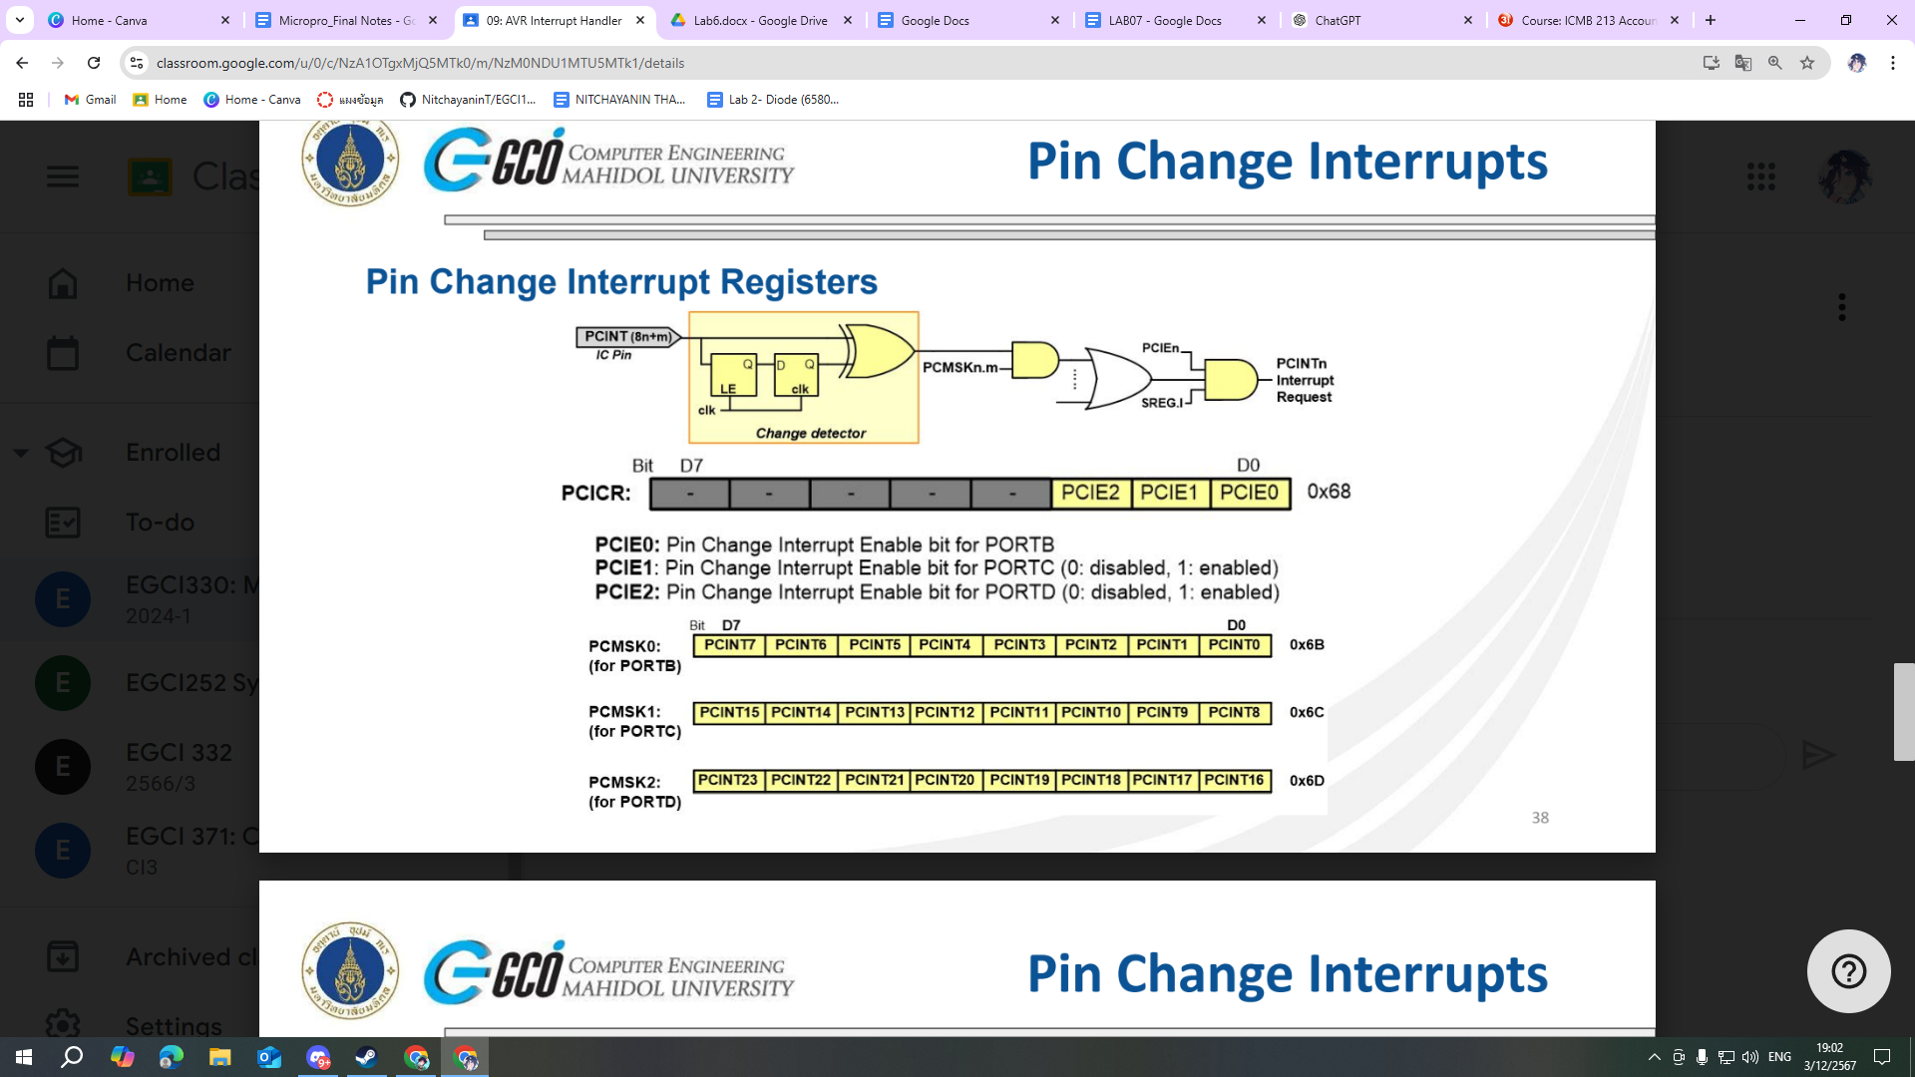

● Pin Change interrupts can occur on all input pins

● On the ATMEGA328P, there are 2 External Interrupts but 24 Pin Change

Interrupts.

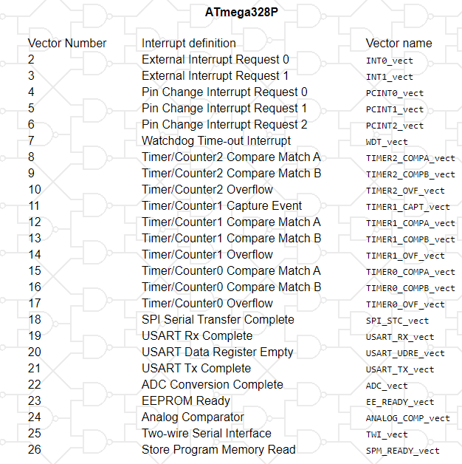

**LCDS**

# 

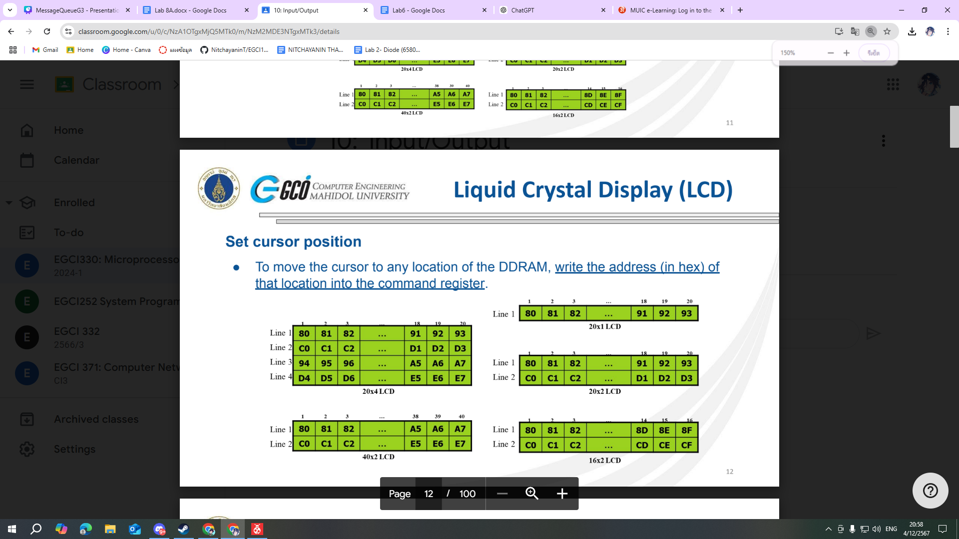

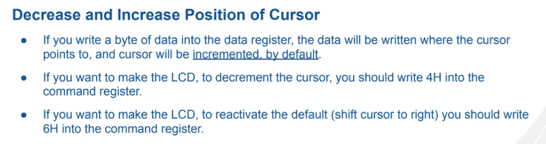

**Enable Pin**

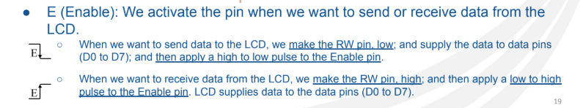

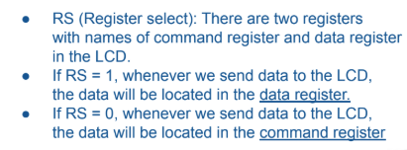

● **Initialization**

○ We must initialize the LCD before we use it.

○ To initialize an LCD, for 5×7 matrix and 8-bit operation, 0x38, 0x0E, and 0x01 are send

to the command register.

**● Sending commands to the LCD**

○ Make pins RS and R/W = 0

○ Put the command number on the data pins (D0–D7)

○ Send a high-to-low pulse to the E pin to enable the internal latch of the LCD (wait

about 100us after each command)

**● Sending data to the LCD**

○ make pins RS = 1 and R/W = 0.

○ put the data on the data pins (D0–D7)

○ send a high-to-low pulse to the E pin (wait about 100us)

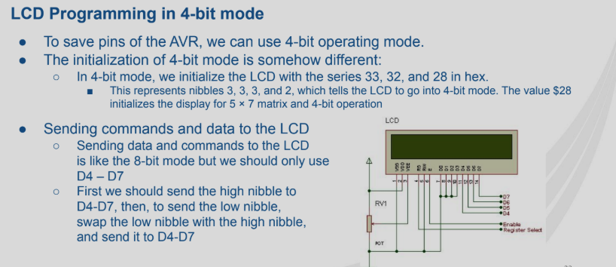

**UART**

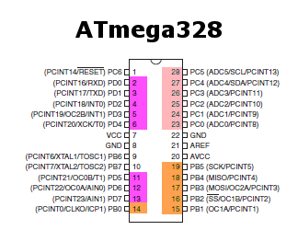

RXD = PD0

TXD = PD1